

Programme Name: ________**BCS HONS**_______________________________________

Course Code: __**CSC 2514**________

Course Name: _______**Artificial Intelligence**_____________________________

**Assignment** / Lab Sheet / Project / Case Study No. _**2**___

Date of Submission: ______**8/10/2021**_____________

**Submitted By: Submitted To:**

Student Name**: Dipesh Tha Shrestha** Faculty Name**: Prakash Chandra**

IUKL ID: **041902900028** Department**: LMS**

Semester**: Fourth Semester**

Intake**: September 2019**

1. **Describe A* Search and its condition for optimality.**

**Answer:** A* Search algorithm is one of the best and popular technique used in path-finding and graph traversals. A* is formulated with weighted graphs, which means it can find the best path involving the smallest cost in terms of distance and time. A* makes use of both elements by including two separate path finding functions in its algorithm that take into account the cost from the root node to the current node and estimates the path cost from the current node to the goal node.

A* Algorithm extends the path that minimizes the following function-

**f(n) = g(n) + h(n)**

Here,

‘n’ is the last node on the path.

g(n) is the cost of the path from start node to node ‘n’.

h(n) is a heuristic function that estimates cost of the cheapest path from node ‘n’ to the goal node.

There are two condition in which A* is optimal, they are:

• The monotonic heuristic condition, if h(n)< h(n+1), then the real-cost(n)< real-cost(n+1)

• The admissible heuristic condition as it will never overestimate the cost.

1. **For the graph given below, use A* algorithm to find the most cost effective path to reach from start state A to goal state G.**

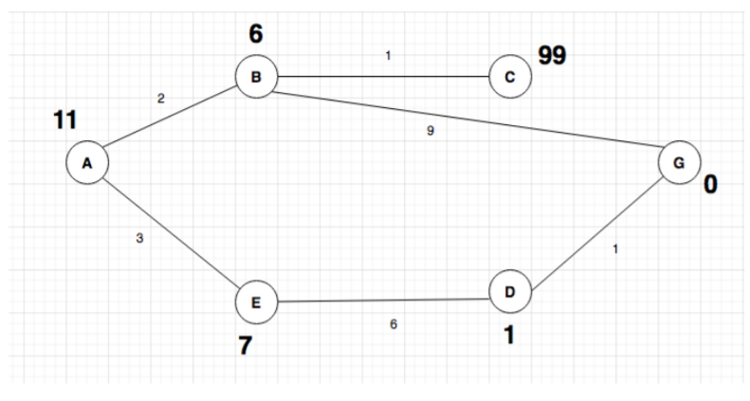

**Solution:**

Let us find the most cost-effective path to reach from start state A to final state G using A* Algorithm.

As mention in note: The numbers written on edges represent the distance between the nodes while the numbers written on nodes represent the heuristic values.

Let’s start with node A.

Since A is a starting node, therefore, the value of g(x) for A is zero and from the graph, we get the heuristic value of A is 11, therefore

g(x) + h(x) = f(x)

0+ 11 =11

Thus for A,

So, we can write A=11

Now from A, we can go to point B or point E, so we compute f(x) for each of them

A → B = 2 + 6 = 8

A → E = 3 + 6 = 9

Since the cost for A → B is less than of A → E, we move forward with this path B and compute the f(x) for the children nodes of B

Since there is no path between C and G, the heuristic cost is set infinity.

A → B → C = (2 + 1) + 99= 102

A → B → G = (2 + 9) + 0 = 11

Here the path A → B → G has the least cost but it is still more than the cost of A → E, thus we explore this path further

A → E → D = (3 + 6) + 1 = 10

Comparing the cost of A → E → D with all the paths we got so far and as this cost is least of all we move forward with this path. And compute the f(x) for the children of D

A → E → D → G = (3 + 6 + 1) +0 =10

Now comparing all the paths that lead us to the goal.

**Therefore, A → E → D → G is the most cost effective path to reach from start state A to goal state G.**

1. **Using appropriate Truth table, prove the following logical equivalences:**

**a) Implication Elimination**

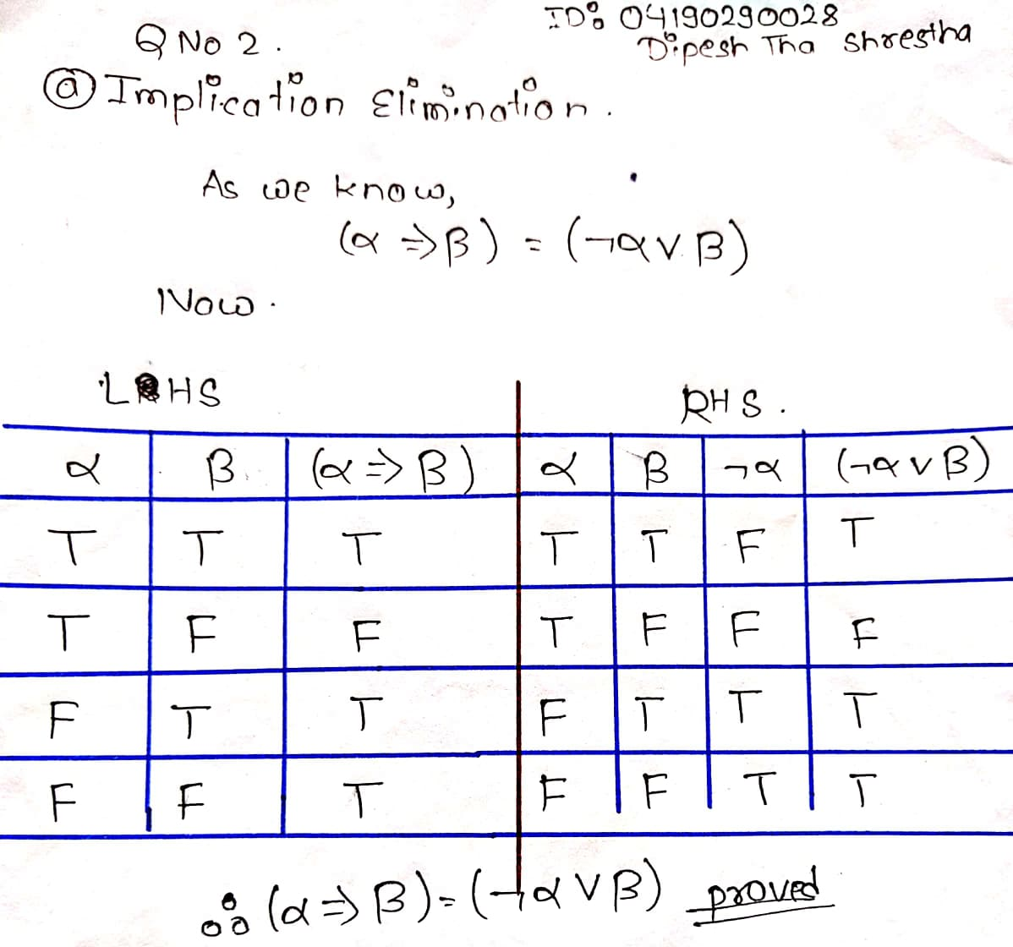

**b) Biconditional Elimination**

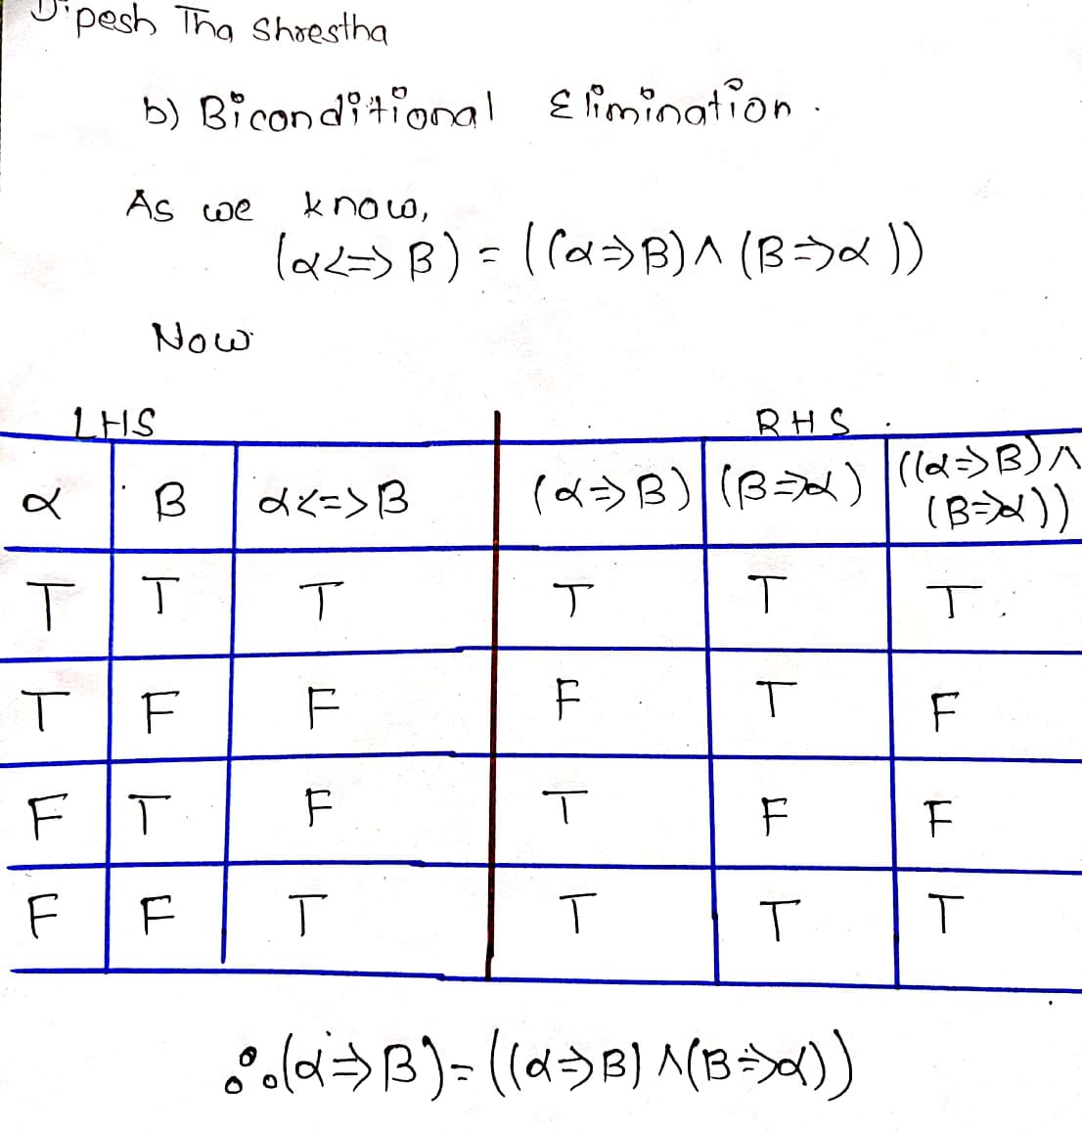

1. **For each english sentence below, write FOL sentence that best expresses its intended meaning:**

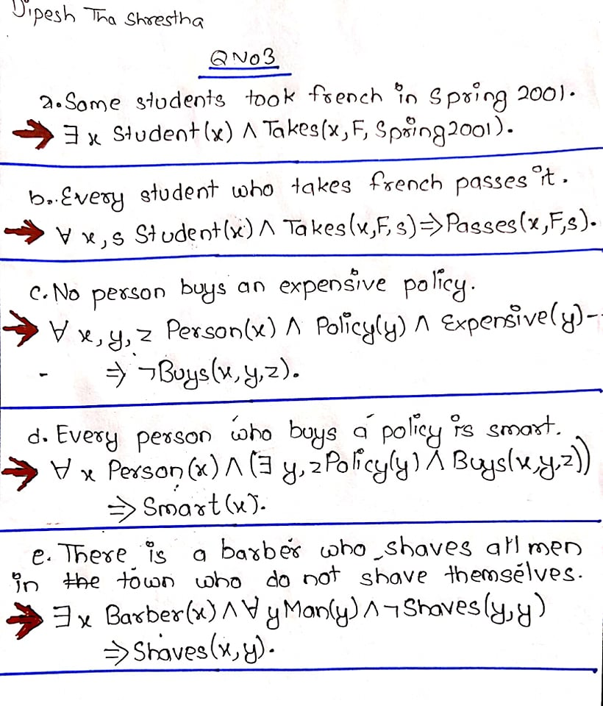

**Thank you**